# Syncytial Aggregate Analysis:

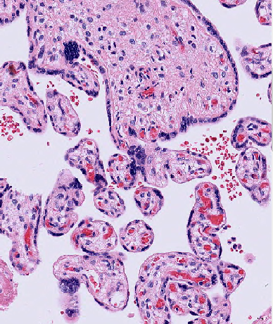 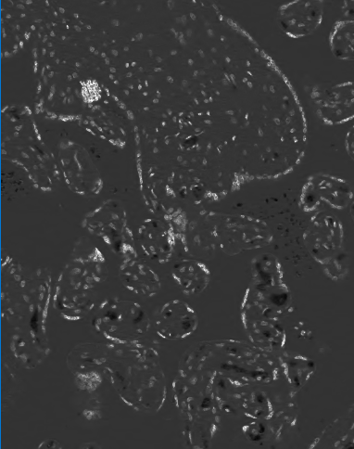 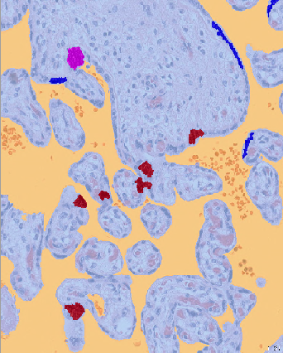 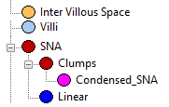

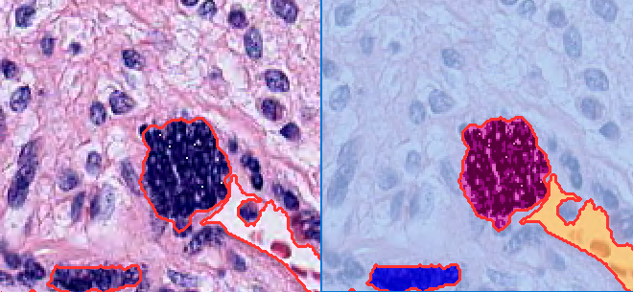 

An image layer is Ratio Layer B = B/(R+G+B) which shows good differentiation between the blue nuclear staining and rest of the tissue. A threshold is applied on Tissue objects and two classes are created Mesenchyme and ‘Blue’. The class ‘Blue’ includes pixels that make up the trophoblasts, nuclei and syncytial nuclear aggregates.

To quantify the differential blue staining, a luminosity layer Is computed as 0.2989* R+0.5870*G+0.1140*B. The 10th percentile and median luminosity value of the pixels belonging to class ‘Blue’ are computed to create 3 bins, Dark (luminosity > 50th percentile), Darker (between 10th-50th percentile) and Darkest (luminosity < 10th percentile)

After computing the threshold values, ‘Blue’ class objects with area less than 500 pixels or width less than 5 pixels are eliminated. The remaining ‘Blue’ objects are classified as ‘SNA’

Based on their width, the SNA objects are classified into Clumps and Linear.

Syncytial Nuclear Aggregate objects have texture that can be expressed by the relative area of the its differential staining. The pixels of the ‘Clump’ objects are binned into ‘Dark’, Darker’ and ‘Darkest’ based on the bin thresholds computed prior. The Relative area of each of these classes is measured for each ‘Clump’ object. Clump objects with relative area of ‘darkest’ pixels greater than 0.5 are further classified as ‘Condensed SNA’.

For each ROI, the following measurements were extracted.

Area of the ROI (sq.mm)

Area of the Villi (sq.mm)

Villous Packing Density = Villi Area/ROI Area

For objects belonging to classes SNA, Clumps, Linear and Condensed Clumps– Count, Total Area, Count per Villi Area is obtained for each group.

Also for pixels that were classified as ‘darkest’ – Total Area, Area of Darkest/Villi Area,

Average Relative Area of Darkest in Clumps

Syncytial Nuclear Aggregates

Linear

Clumps

Other clumps

(Rel. area of darkest pixels < 0.5)

Condensed clumps

(Rel. area of darkest pixels >=0.5)

**Different sheets for the Syncytial Nuclear Analysis Program**

UNC Data – 90 cases with wide range of birthweight with no adverse outcome.

270 ROIs (3-4 per case)

1. Single ROI_SNA_v18_with expertcounts.xlxs

50 ROIs were evaluated by pathologist who counted and marked different types of SNA on screenshots of the ROIs. Columns also include measurements from automated image analysis.

1. UNC_BirthWt_ROI_SNA_v18.csv

270 ROIs from 90 cases

1. Villi Analysis

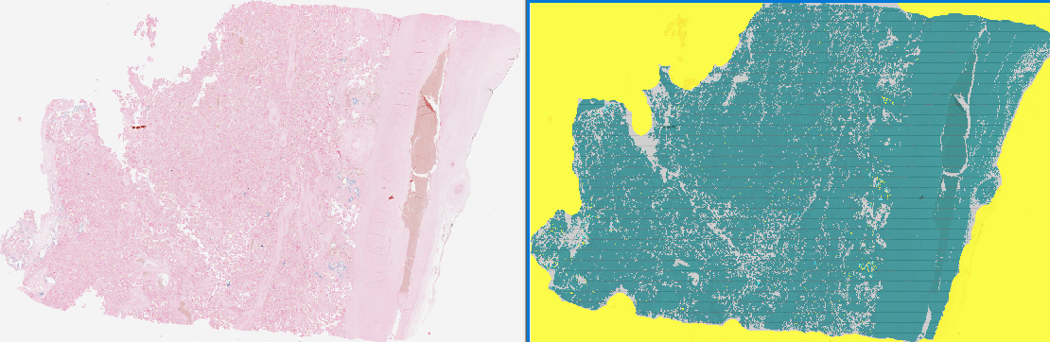

**Quantification of Hemosederin staining on whole tissue slide**

Batch processing of whole slides is carried out using the image analysis software Definiens Developer. The whole tissue is extracted at low resolution of 2.5x

The tissue is then divided into square tiles that are then analysed at higher magnification of 10x.

The intervillous space and Villi areas are segmented out.  In the villi areas the blue hemosederin staining is picked up. Based on the size of the blue staining, they are grouped into different size groups and the total area of each group is calculated.

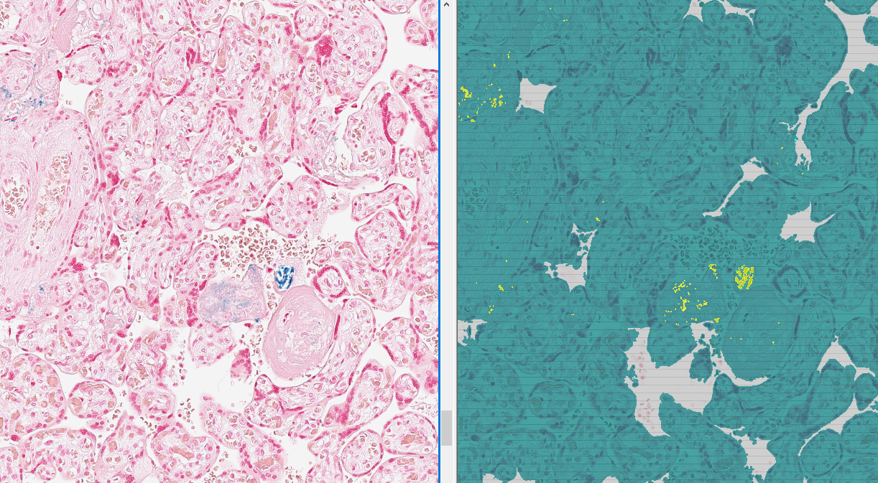

Large blue staining clumps are usually found in areas of calcification while smaller, discrete staining is found within the terminal villi

Total Area of (Blue Stain Clumps >10000 pixels)

Total Area of ( Blue Stain Clumps  5000-10000 pixels)

Total Area of ( Blue Stain Clumps  2000-5000 pixels)

Total Area of (Blue Stain Clumps <2000 pixels)

Hemosederin Stain Quantification -

1. Compare image analysis measurements 10x vs 20x analysis.

HemosiderinStatistics_NYMH_10x.csv

HemosiderinStatistics_NYMH_20x.csv

1. Compare EARLI vs. NYMH

HemosiderinStatistics_EARLI_20x.csv

HemosiderinStatistics_NYMH_20x.csv

Automated ROI selection at 2.5x for downstream SNA analysis at 20x

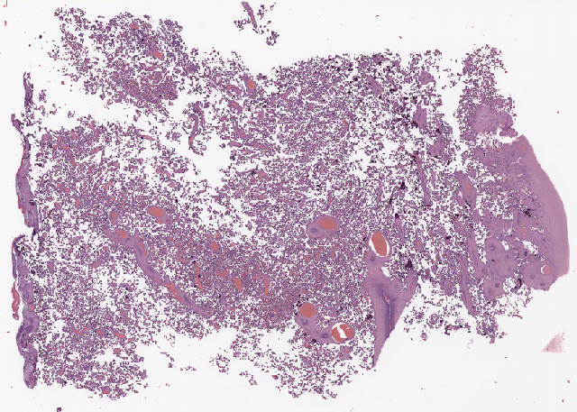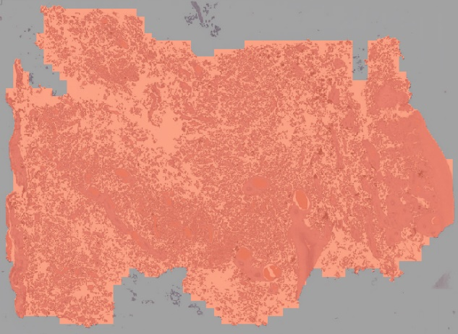

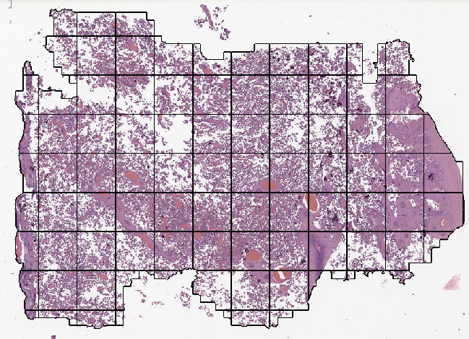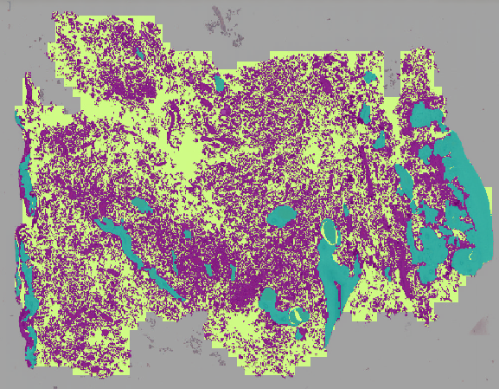

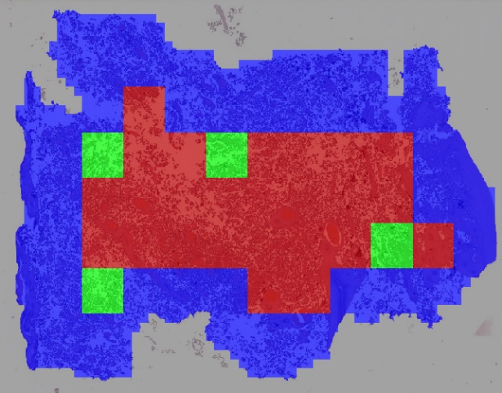

**Automatic ROI selection from Whole Slides**

The whole slide acquired at 20x magnification (resolution 0.5 µm) is downsampled to 2.5x magnification (resolution 4 µm). On this downsampled image, a threshold is applied to segment placental tissue foreground and white background. Morphological operations as closing and region growing are used obtain a single whole tissue object. The whole tissue area is then further segmented and classified into 3 different classes based on pixel features.

Intervillous space (white) , LowSD_Areas and Terminal Villi Area

Nonwhite foreground is spilt into square areas (10x10 sqpxl) and square with low variance in pixel intensity in R channel, indicates sparse nuclei and are classified as “LowSDAreas”. The LowSDAreas includes large stem villi, infarcts, large fibrin and chorionic vessel regions which are characterized by sparse nuclei. The rest is classified as Terminal Villi Area.

The whole tissue (all 3 classes) is divided into 4 sqmm square grids. Areas at the tissue border and squares adjacent to them are excluded. Squares with a relative area of villi area less than 80% as well as those with relative area of ‘LowSDAreas’ greater than 10% are also excluded from further analysis at higher resolution. Each of the squares has an object ID assigned by the software. Random squares can be selected for further downstream analysis at higher 20x magnification.

**ROI Image Analysis at 20x magnification**.

A threshold was computed for each ROI using the ‘Automatic Threshold’ algorithm to segment tissue from the background. This algorithm uses a histogram-based technique to calculate an optimal threshold dividing the selected set of pixels into two subsets, such that heterogeneity is increased to a maximum. (Definiens Reference Guide). Challenges include the presence of maternal blood cells, that make it difficult for the software to distinguish between true blood vessels belonging to villi and intervillous space.

**Syncytial Aggregate Analysis:**

**Folder WholeSlideSNA** Raw ROI summary files from different disease group slides

ObjectStatistics_ROI_PE.csv

ObjectStatistics_ROI_GDM.csv

ObjectStatistics_ROI_Norm.csv

ObjectStatistics_ROI_FVP.csv

Also, single row summary for single case normalized by Villi Area.

SingleLabID_NormbyVilliArea_2.csv